Ec2 Task

- Launch one EC2 using Amazon Linux 2 image and add a script in user data to install Apache.
sudo yum install httpd
sudo systemctl start httpd
sudo systemctl enable httpd
sudo systemctl status httpd

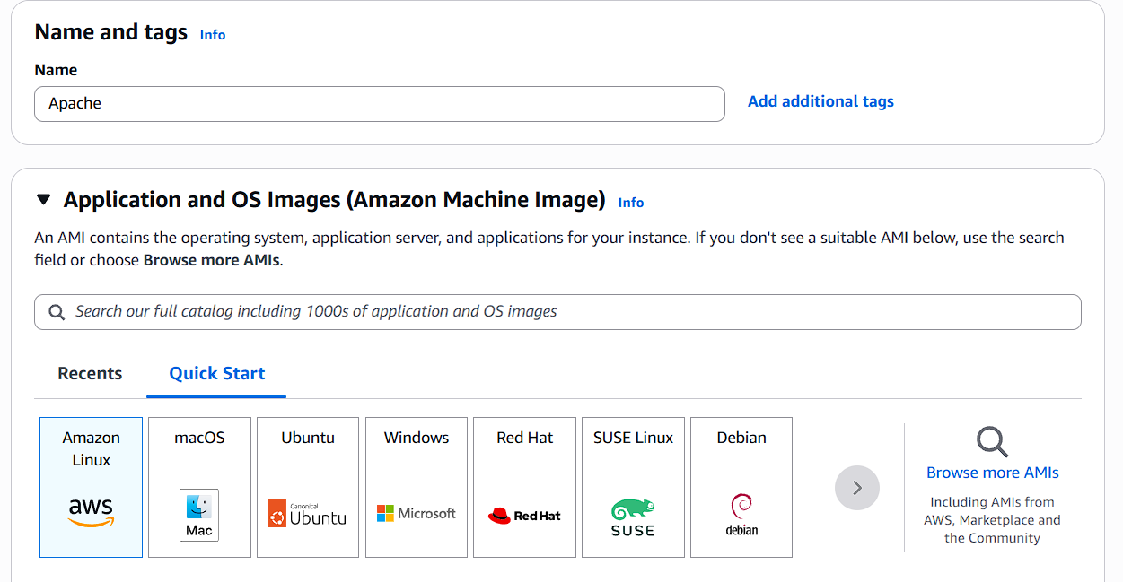

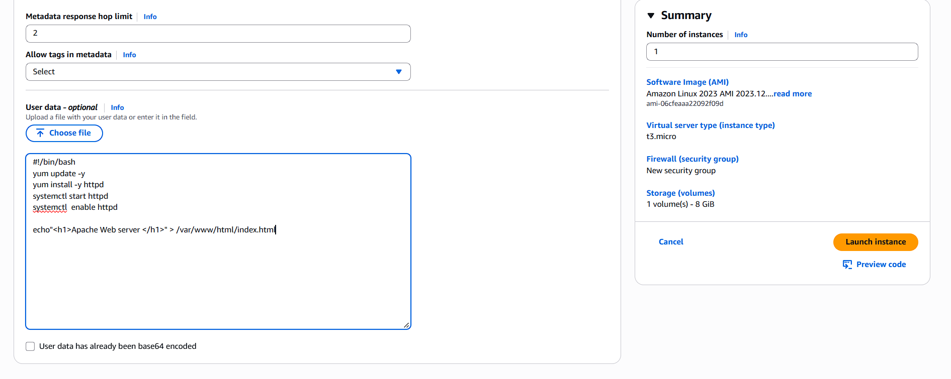

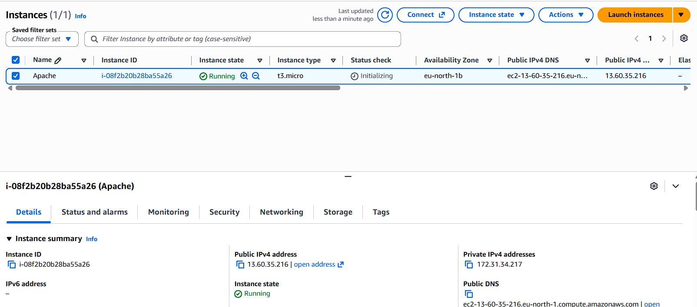
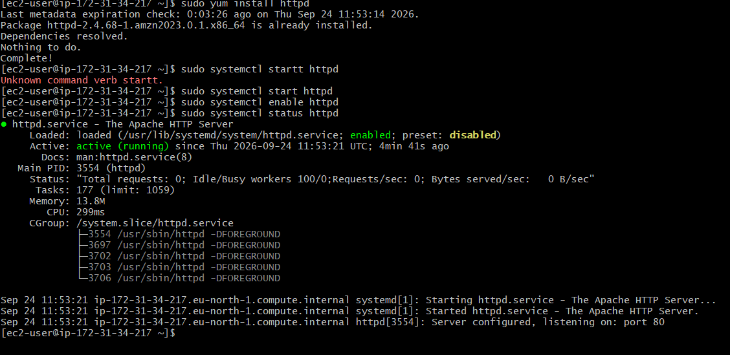

2. Launch one EC2 using Ubuntu image and add a script in user data to install Nginx.
a)Sudo yum install nginx
b)sudo systemctl start nginx

c)sudo systemctl enable nginx

d)sudo systemctl status nginx

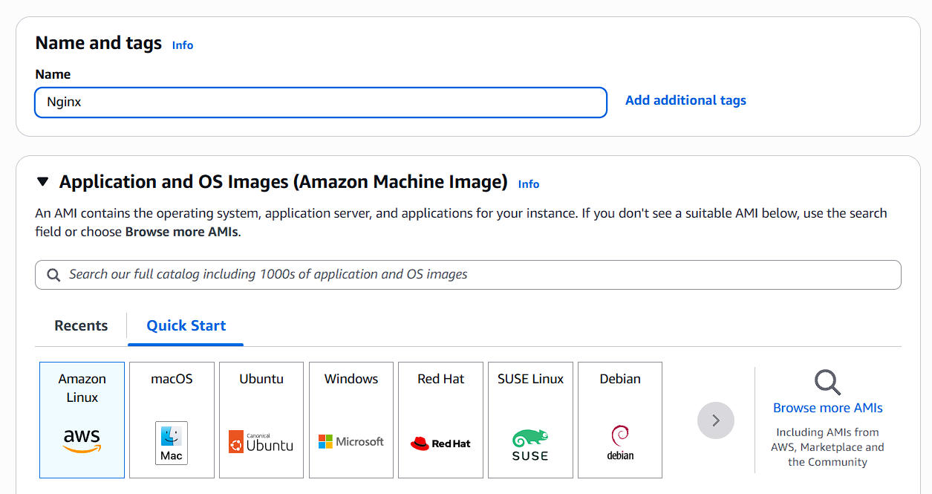
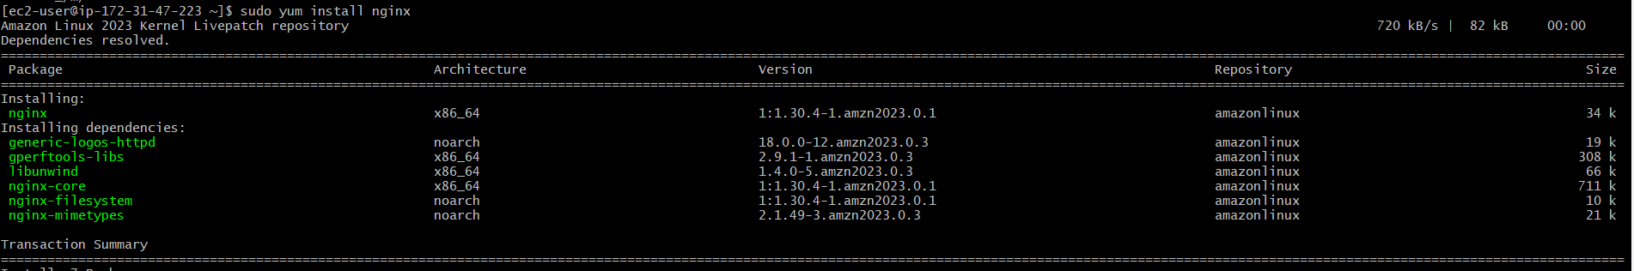
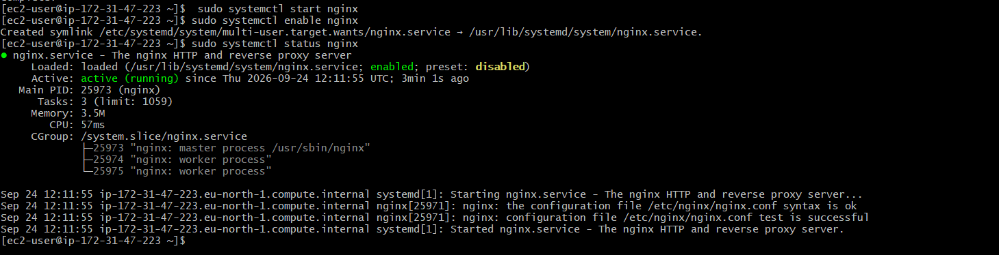

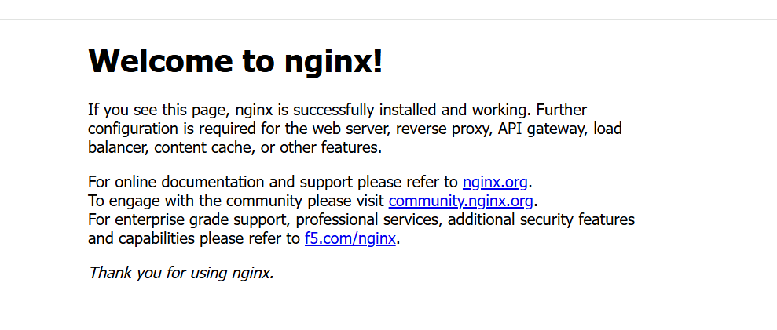
3. Launch one windows server and install tomcat on windows
Note : All the commands executed in the windows powershell
Steps : 1)winget install --id EclipseAdoptium.Temurin.21.JDK --exact --source winget (Java Installation)
2)Java -version(To check the which java version is installed)
3)cd C:\ (Switch to c directory)
4) Invoke-WebRequest -Uri "https://dlcdn.apache.org/tomcat/tomcat-10/v10.1.49/bin/apache-tomcat-10.1.49-windows-x64.zip" -OutFile "tomcat.zip" ( It help to install the tomcat in powershell )
5)Get-Item C:\tomcat.zip (To check the tomcat installed or not)
6)Expand-Archive -Path "C:\tomcat.zip" -DestinationPath "C:\" (To extract the tomcat file)
7)Get-ChildItem "C:\Program Files\Eclipse Adoptium" -Directory | Where-Object { Test-Path "$($_.FullName)\bin\java.exe" }

8)$jdk = Get-ChildItem "C:\Program Files\Eclipse Adoptium" -Directory | Where-Object { Test-Path "$($_.FullName)\bin\java.exe" } | Select-Object -First 1
9) [Environment]::SetEnvironmentVariable("JAVA_HOME", $jdk.FullName, "Machine")
10) C:\apache-tomcat-10.1.60\bin
11) .\catalina.bat run (By this command we can know tomcat is running)

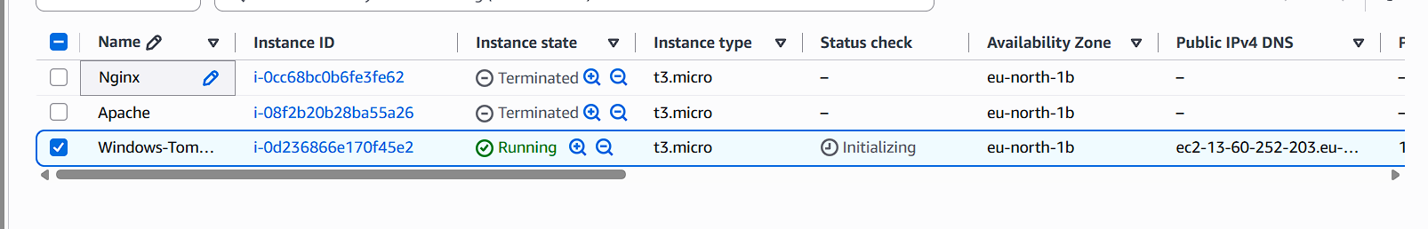
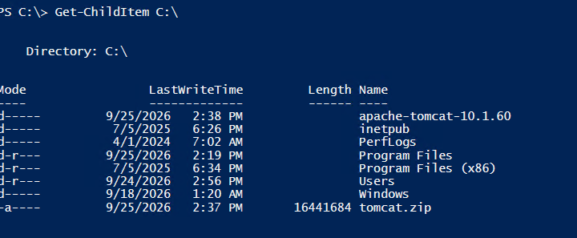
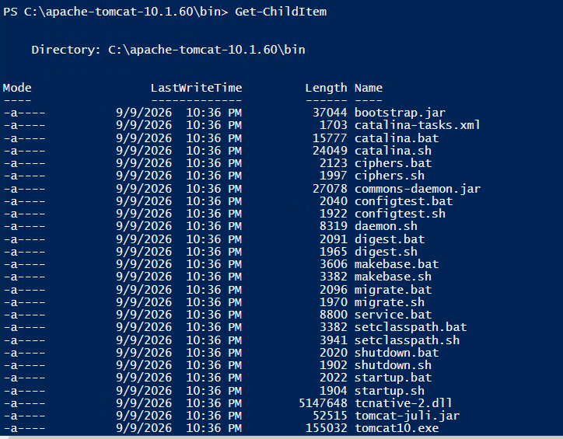
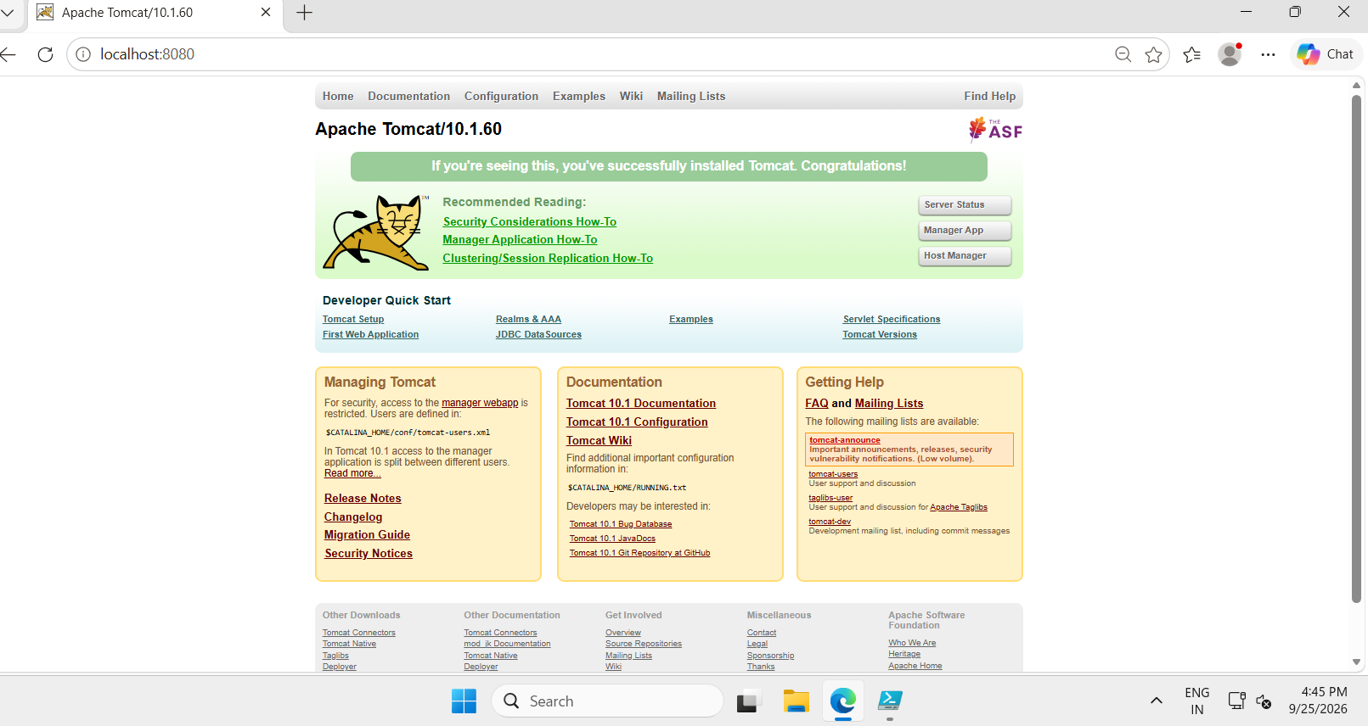

4.Take a snapshot of the instance created in Task 1.
a)Open AWS Console → EC2.
b)In the left side, find Elastic Block Store.
c)Click Volumes.
d)You will see your EBS volumes.
e)Open AWS Console → EC2.
f)In the left menu, find Elastic Block Store.
g)Click on Volume.
h) You will find your EBS volumes.
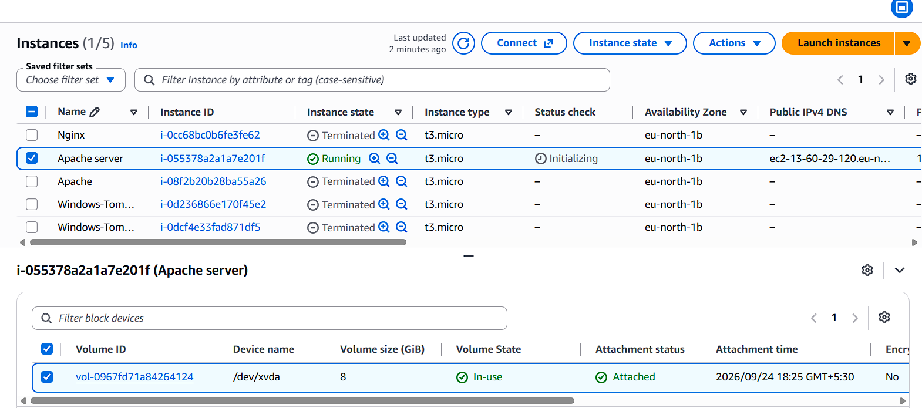
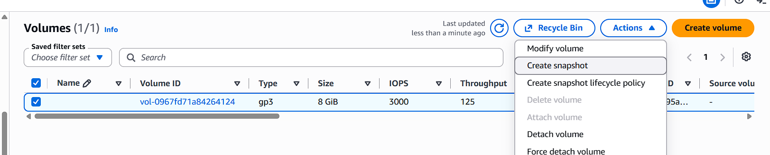
Steps to create a snapshot
• Select the volume attached to your EC2 instance.
• Click Actions at the top.
• Select Create snapshot.
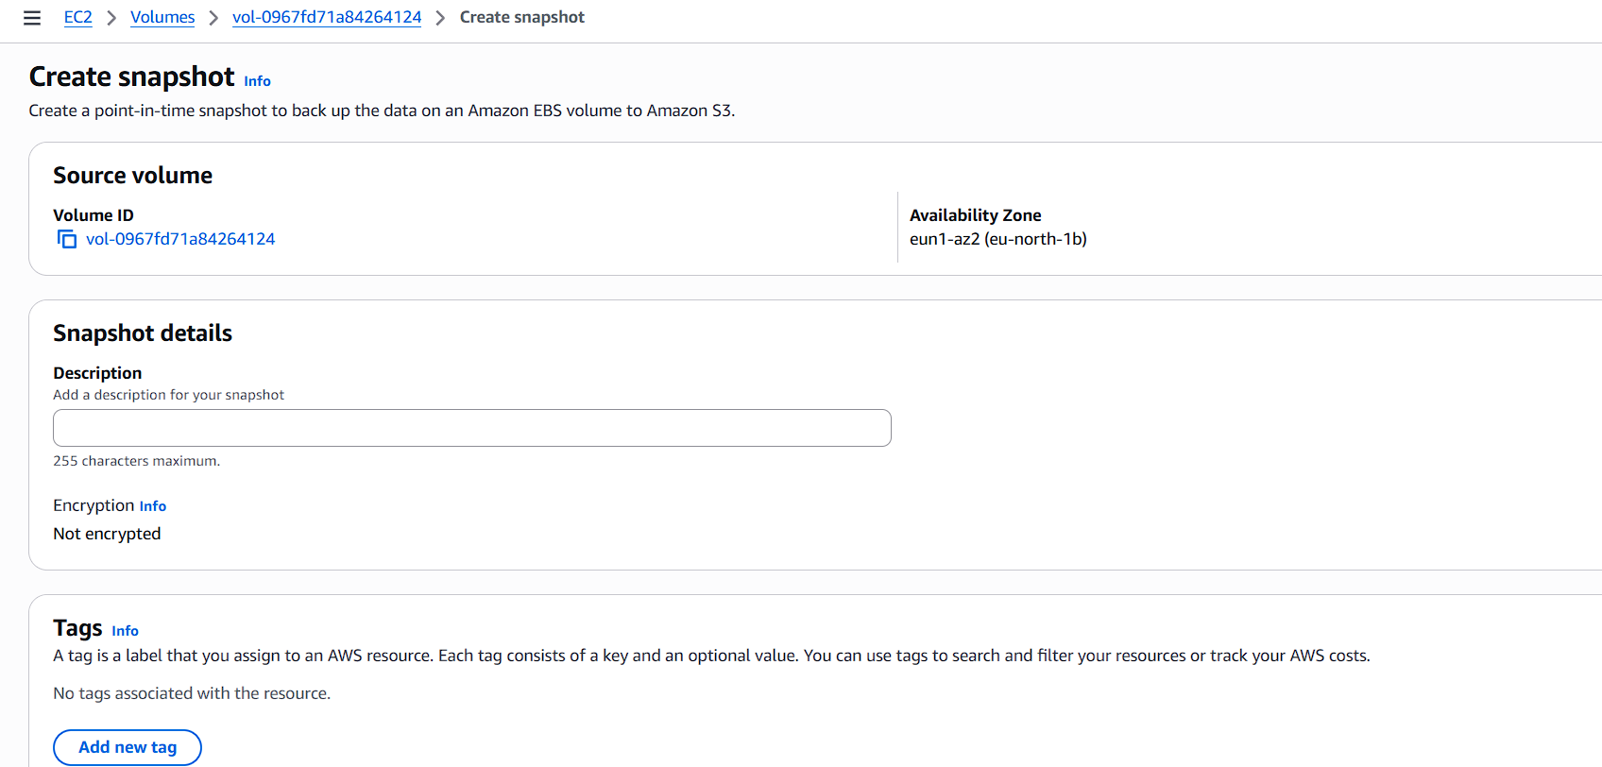
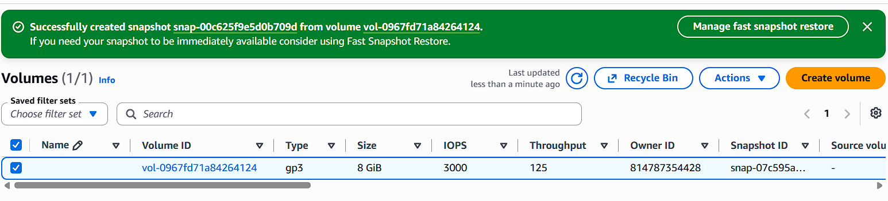
Go to snapshot in the left side
click on snapshot
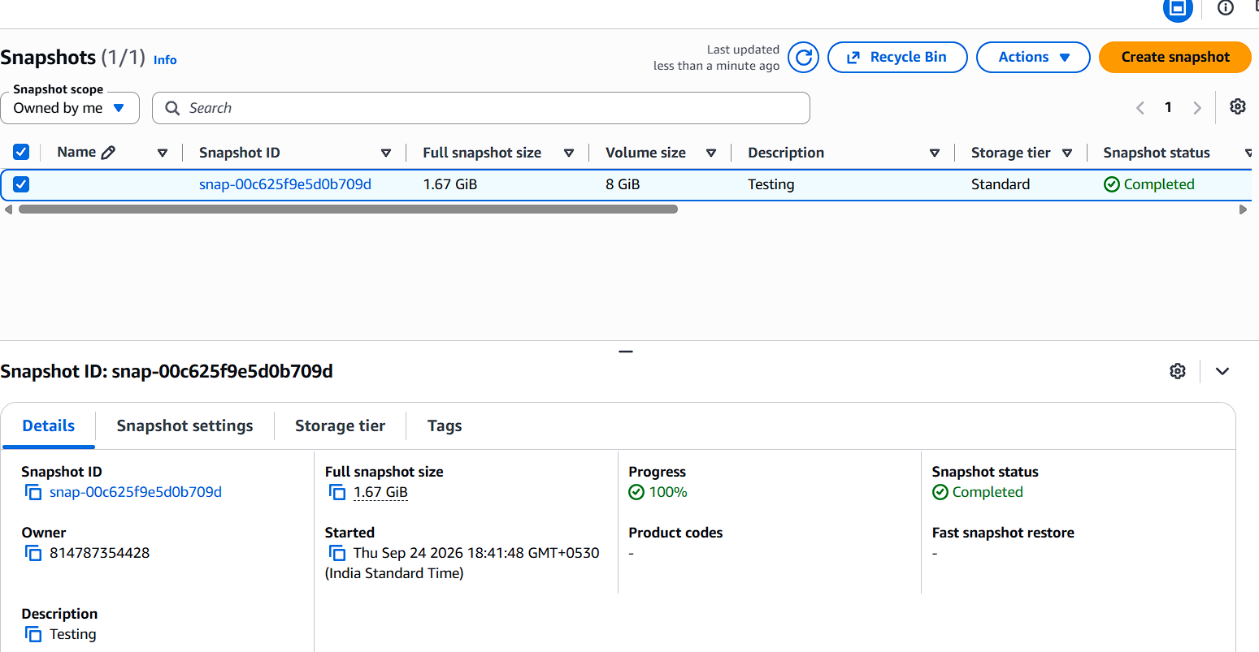

5.Assign password less authentication for the EC2 created in Task 2.

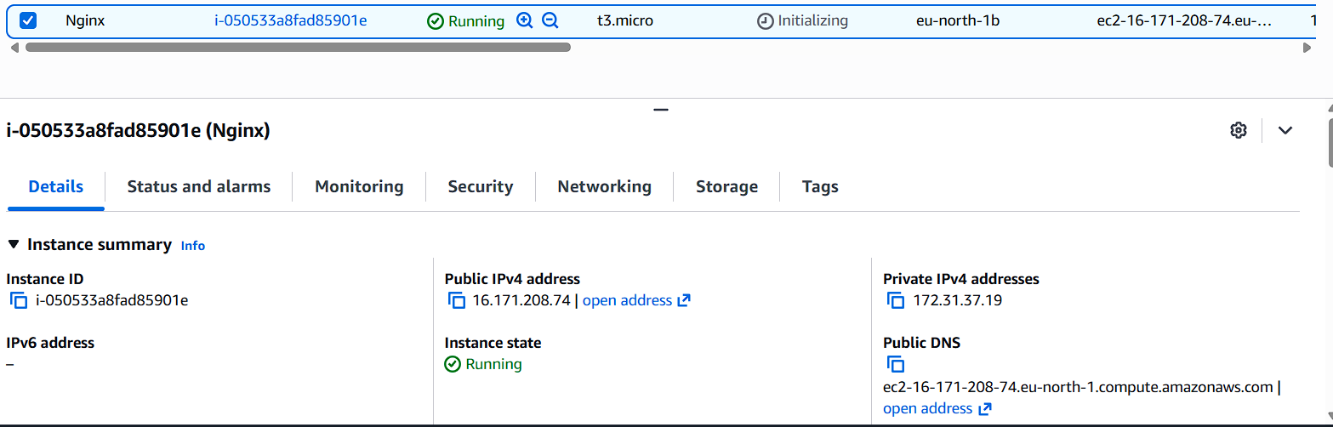

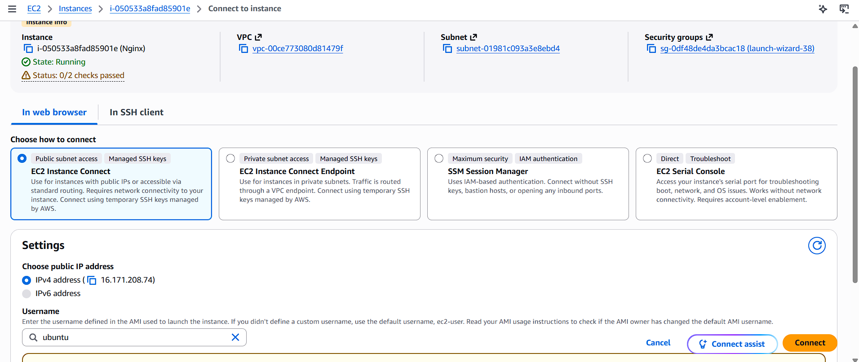

6.Launch any EC2 using the spot purchasing option.

1) Go to EC2 → Instances.
2) Click Launch instance.
3) Scroll to Advanced details.
4) Find Purchasing option.
5) Select Spot Instances .
6) Configure the instance and click Launch instance.

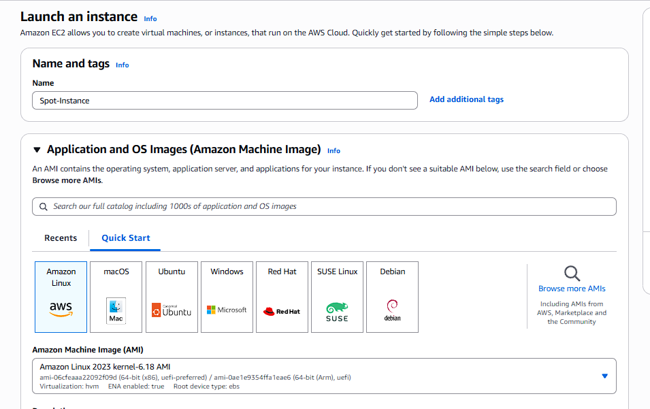
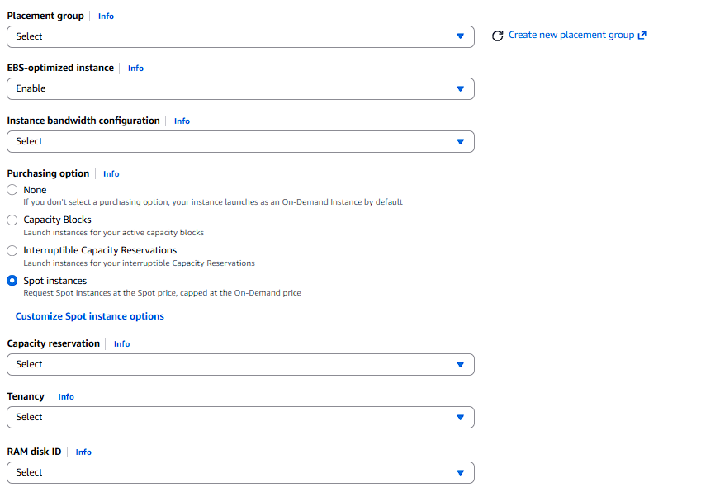

7. Enable termination policy on the EC2 created in Task 2.

a)Open AWS Console → EC2.
b) Click Instances.
c)Select the EC2 instance you created.
d) Click Actions.
e)Choose Instance settings.
f) Click Change termination protection.
g) Select Enable.
h) Click Save.
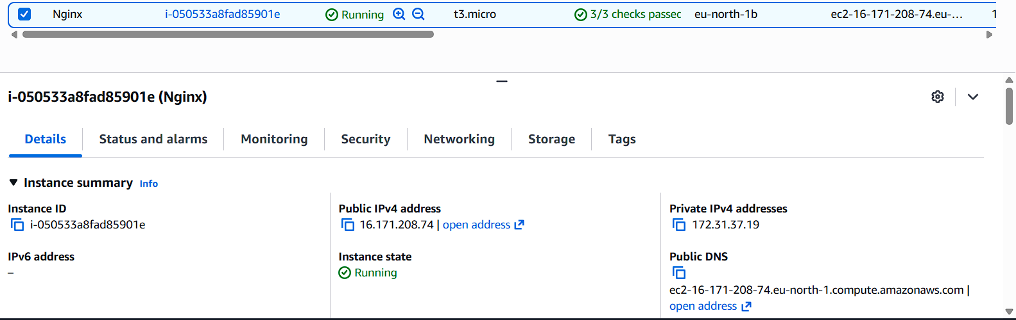

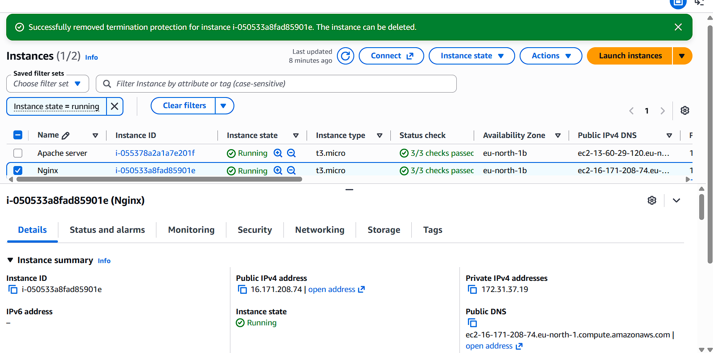

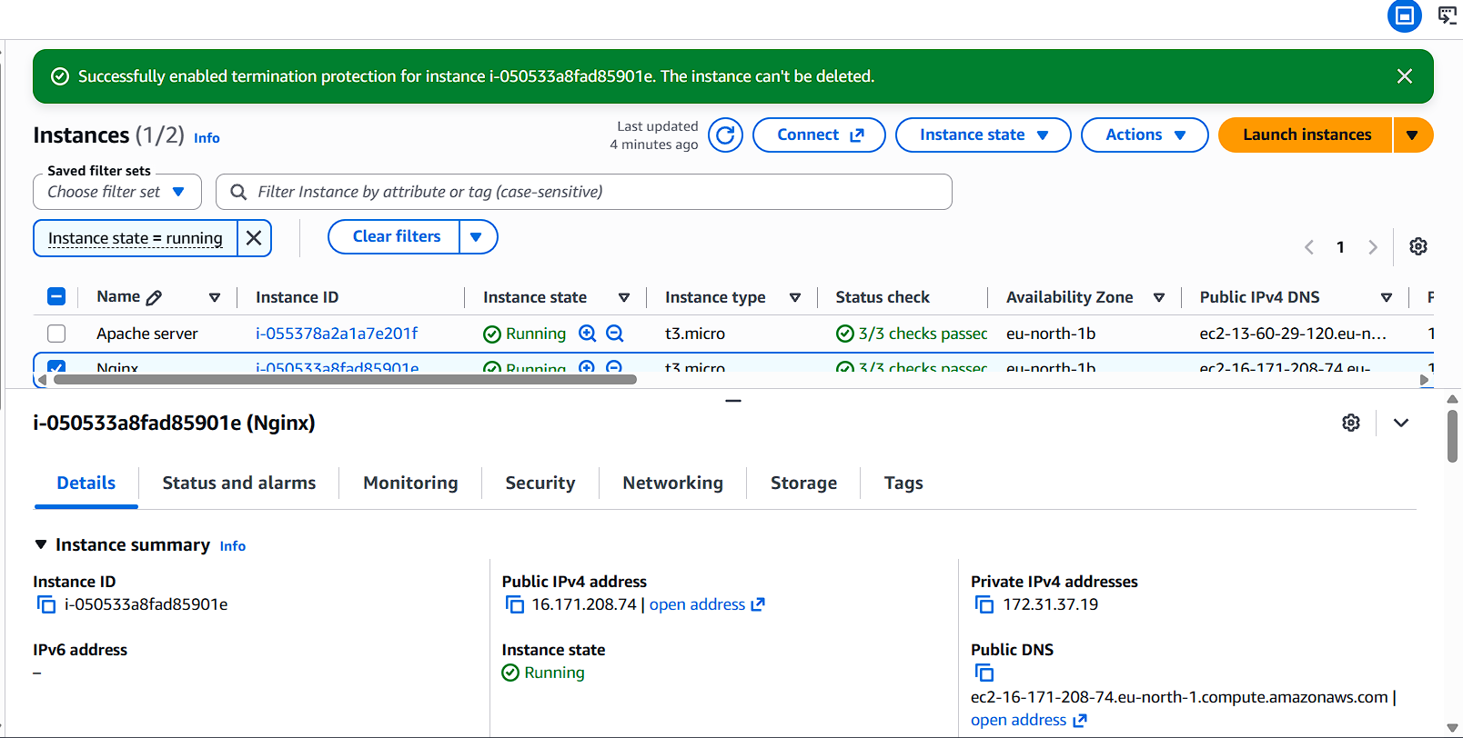

8. Launch one EC2 using AWS CLI.

